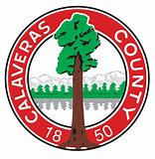
SUPERVISOR – DISTRICT 4 DENNIS MILLS
CALAVERAS COUNTY GOVERNMENT CENTER.
891 MOUNTAIN RANCH ROAD
SAN ANDREAS, CALIFORNIA 95249-9709
(209) 754-6370 or (209) 286-9050

Evaluating the Winter Levels
of Lake Tulloch
A Discussion Paper Prepared by
Calaveras County Supervisor Dennis Mills
October 2018

Introduction

The idea of creating Lake Tulloch was proposed in the 1880s with Charles H. Tulloch who acquired a small ditch and water rights in the Central Valley of California. The ditch was originally made by miners for placer gravel. Central valley farmers discovered it could be a great resource to irrigate their crops. The ditch was widened by farmers and soon was irrigating 6,000 acres in Oakdale and South San Joaquin. The water was primarily supplied by Stanislaus River.
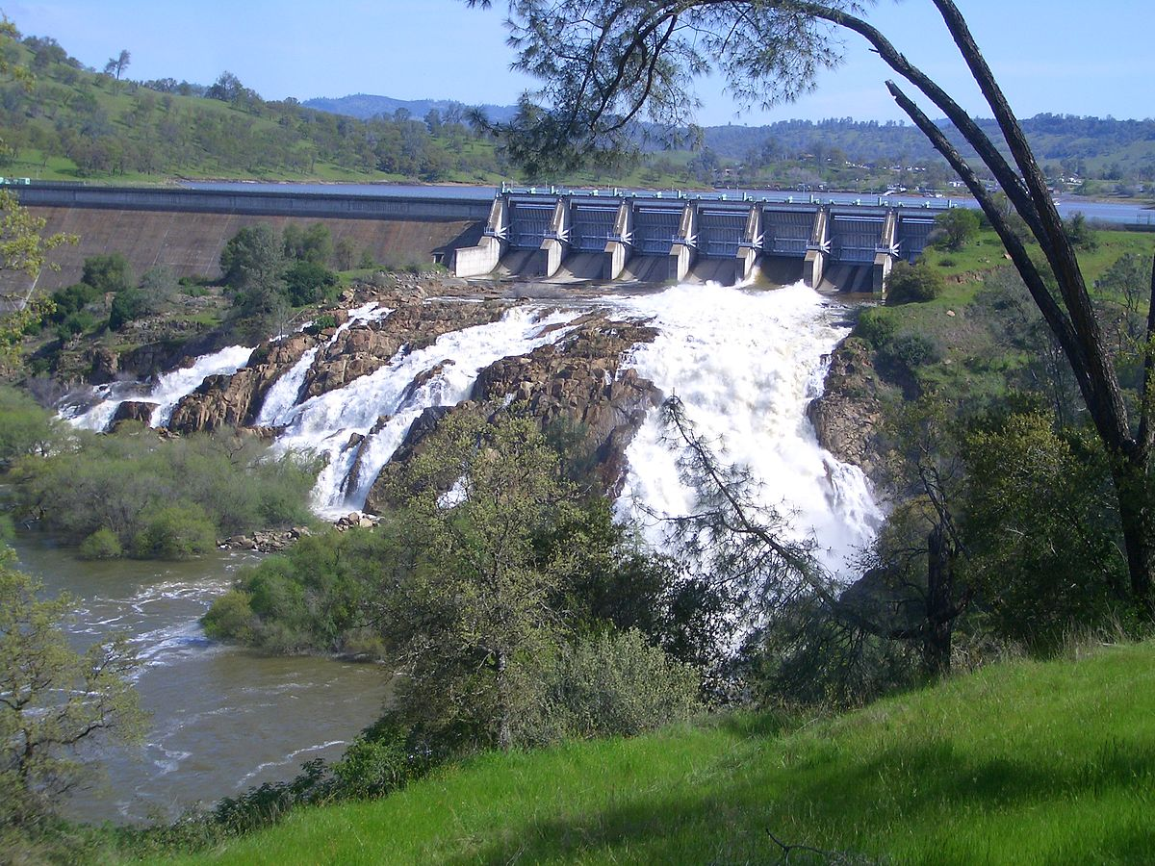
According to the US Department of Interior, the U.S. Congress passed the Reclamation Act of 1902 which created the Reclamation Service, now the Bureau of Reclamation. Around the same time, local irrigation districts were created in the foothills. Two of these, the Oakdale and South San Joaquin Irrigation Districts constructed the 211 foot (64 m) high old Melones Dam in 1926 to provide water for agriculture. This original reservoir stored 112,500 acre-feet of water. It was replaced by the much larger New Melones Dam in 1978 which holds 2.4 million acre feet.

The Oakdale Irrigation District (OID) and the South San Joaquin Irrigation District (SSJID) paid $650,000 to co-own water rights from Tulloch's expanded ditch on the Stanislaus River in July 1910. The districts received their first license from the Federal Energy Regulatory Commission (FERC) to begin the Tulloch Project in 1955 with the Tulloch Dam built in 1957. The project was called the Tri Dam Project since it included two other dams up stream. It was founded as a Joint Power Agency or Agreement.

The federal permit was effective January 1, 1955 through December 31, 2004^{[3]} Two years later, the districts received another license on February 28, 2006 that would give them an additional forty years to operate and expire on January 1, 2046.

The Uniqueness of Lake Tulloch

Lake Tulloch is unique among reservoirs permitted by the Federal Energy Regulatory Commission since most of the property along the shoreline and under the lake is owned by private property owners who possess fee title to the property.

Currently all private property owners, abutting Tulloch, own the land under the water below the 515-foot elevation. Some properties own to the center of the river and others have a property line that is a specific distance under the water. Most of these transfers occurred, in the early 1990’s, when the original owners of the underwater land, in an effort to reduce their liability, transferred title to the portion of the area under water to the adjacent parcel owners. This is unique in that only five reservoirs west of the Mississippi have this situation.

For the past several decades the Tri Dam Authority has assumed all land use authority on the lake and has granted and denied permits along the lake shoreline without approval or involvement of the counties planning and/or building departments. Under the United States Constitution states are granted powers that include land use authority which they usually delegate to local government, namely cities and counties.
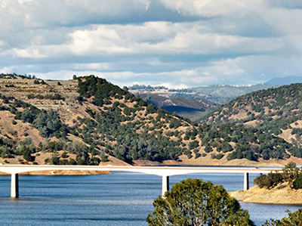
The work to fill New Melones was completed in 1982 and included a state ballot initiative called Prop 17 in 1974 that tried to limit its filling. I was the Executive Secretary of Fill the Dam during that time and worked with the Army Corps, Bureau of Reclamation and local interest groups to keep the Stanislaus from becoming a federal Wild and Scenic River. I bring this up only to indicate my personal involvement with New Melones and Lake Tulloch spans forty years. Many will say they have historical knowledge of the events of the 1970’s and 80’s. My knowledge is personal because it was part of my life back then.

Lake Tulloch and Land Use

The provision for the development of private property along nearly all of the lake’s 55-mile shoreline resulted in the development of a community housing now as many as 5,000 residents. Businesses have grown up over the years with a shopping center, office and light industrial buildings, the Copper Town Square complex, and many residential developments. Two restaurants are now open year round on the shoreline offering employment opportunities for residents along with other commercial development. Whether or not this was the original intention of the two irrigation districts, this has been the result.

Therefore, the existence and operation of the reservoir has a direct relationship to the community. For a half century the reservoir depth has varied with lower fall/winter levels and full levels in late spring and summer to accommodate flood events. With the growth of the community and potential long term growth along with great weather in our region, many residents have proposed that the appropriate federal and local agencies consider maintaining the lake at a higher level year round. This paper addresses this question.

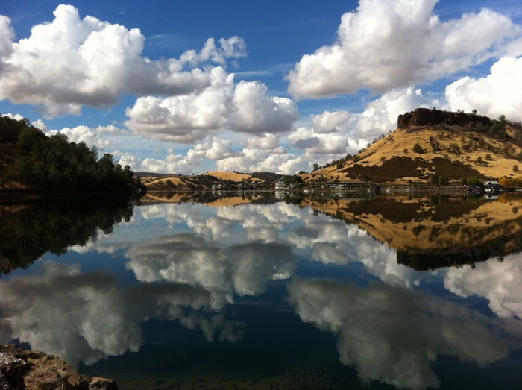
Understanding the Historic Operation of Lake Tulloch

In 2015 the Tri-Dam Joint Powers Authority (JPA) renewed their operating conditions with the Federal Energy Regulatory Commission (FERC) on how Lake Tulloch would be operated for the next forty-year cycle. In doing so, all previous agreements, amendments, and alterations were codified under what is now known as the 2015 Shoreline Management Plan (SMP). Local residents were very involved in making comments and asking for specific policies that were considered as part of this SMP. Their comments are included in the SMP for those that would like to better understand their concerns.

What makes Lake Tulloch unique within the realm of FERC is that it is one of five reservoirs west of the Mississippi that is federally regulated with private property owners having rights to the use of the lake. Let me say again, it is federal water.

Water Levels - To further understand the issue, in discussions on what is the agreed elevation to the flowage easement, there is a difference of opinion with Tri-Dam using the top of the dam to determine 510-foot elevation for maximum pool and Federal Emergency Management Agency (FEMA) working from outside the basin inward to set 513.9 feet as their elevation for 100-year flood events. As a result, we need to use the more cautious approach of the FEMA elevation when making decisions due to inflows within the basin and not for what may come from New Melones in major storm events.

New Melones and Tulloch Reservoirs – New Melones and Tulloch Reservoirs are tied together. The original Melones reservoir was built by Tri Dam. Therefore, there are three important questions to consider:

- Why did the federal government take over the building of New Melones Dam?
- What were its original purposes?
- How do the purposes of New Melones affect how Lake Tulloch operates today?
Tri-Dam JPA was the original project owner but the cost of this dam exceeded their ability to complete the work. In giving up the project to the federal government, Tri-Dam JPA reached an agreement for how much of their water could be stored there and who had first rights. The original design included three purposes:

- Flood Control
- Irrigation
- Recreation
The power component was added later. It is the installation of the Francis turbines that required Lake Tulloch to alter its use as an after bay to New Melones.

There are two important points here:

- Power Generation in New Melones and Tulloch - There needs to be a specific minimum elevation in the after bay to create the needed back pressure for those turbines to operate. Should Lake Tulloch be lowered below that elevation, the turbines at New Melones would go idle and would not generate power. Part of that power is supplied to our local government agencies at very low rates, which does include your local water/sewer district. That is the reason Lake Tulloch must not be drained or lowered. Without a full Tulloch, should New Melones drop to near dead pool as it did 2015, there would be no power generation. That would mean high power cost for our local government agencies.

- Flood Control – Another key element of Lake Tulloch’s agreement is to use it as a regulating reservoir to reduce the shock of New Melones outflows downstream in major storm events. New Melones has proved many times since the storms of 1982, that it can handle the upstream flows and protect cities downstream from inundation and saving millions of dollars in potential damage. New Melones has also shown it is capable of regulating the flows without Lake Tulloch. Winter drawdowns with the exception of the five-year event to check the gates has proven many times over to be of little value as New Melones can hold back the massive flows upstream.
For example, in October 2018 New Melones Reservoir is at 80% of its capacity of 2.4 million-acre feet leaving about 500,000-acre feet available for additional inflows from the Sierra. In comparison, Lake Tulloch’s capacity is approximately 67,000 acre feet when full or about 2.7% of the capacity of Melones. During the months of October to April when it is lower, it contains about 56,000 acre feet of water leaving about 11,000 acre feet for flood control.

Therefore, at this time, Lake Tulloch only has the ability to hold only .02 of one percent of the flood control capacity of New Melones.

It is more important to consider storm water inflows into the Lake Tulloch basin, rather than the much larger releases of the Sierra snowpack through New Melones. Any changes in elevation to current Tulloch levels must consider how such inflows impact the reservoir and its own releases downstream on the Stanislaus.

Misleading Information on Tulloch’s Operation - In reviewing some comments on social media, we have identified some serious misinformation. One post contended that some special agreement existed to keep Tulloch full during the 2015 drought when other lakes were drained. That is completely incorrect. The fact is that what kept Tulloch full was a strong working relationship between Tri Dam, local residents, and our Congressman. Hundreds of our citizens spoke out and Congressman Tom McClintock personally intervened in meetings with the Director of the Bureau of Reclamation in Washington, D.C. during that critical time.

There are many lakes in California that during the drought years of 2010 to 2015 remained full or near capacity for various reasons. Unfortunately, New Melones was drained down in order to comply with the California State Water Board’s demands for more water to encourage fish flows into the Delta and Bay. New Melones was drawn down to about 11% of its capacity. That was shameful and dangerous. The draw down actually damaged the environment, ecology, and economy of the region.

Unfortunately, several social media posts alleged that if policies were changed to allow for Tulloch to be maintained at a higher level, that this decision would make it easier to drain it. That is a false statement. One key point is that as long as New Melones is capable of generating power, Lake Tulloch will never be lowered to dead pool.

Lake Tulloch Today

As noted earlier, over the past 60 years the communities and land surrounding Lake Tulloch have changed. In 1958, there were more cows living around the lake than people. It was just ranch land and open space. Over the years that changed with the creation of the Poker Flat and Copper Cove developments and some limited commercial areas. In the past 10-15 years residential and commercial development have grown significantly. The area has become a major economic asset to Calaveras County. The lake itself is the greatest asset for the area and has driven growth. However, this has occurred with a lake level that fluctuates significantly. Over the past 60 years each September the lake is lowered at least 10 feet and then eight months later is raised up to its capacity.

This discussion paper addresses the question of the potential of ending this fluctuation by accessing the impact of a new policy that would maintain lake at a near full capacity year-round why addressing the needs of the Tri Dam Authority for the maintenance of the reservoir.

Nearly 500 citizens have signed a petition urging the careful consideration of the potential to maintain the lake at a higher level most, if not all year long. These citizens believe such a proposal needs to address the maintenance and operational needs of Tri Dam. It is important note that some of the best weather in the region is in September (high 90°), October (high 78°) and November (high 65°). The months of March and April and May are 65-69 degrees. Therefore, the actual boating season could more than double by maintaining the lake a higher or near full level year round. We know that when the water is lowered even experienced fishermen can’t launch their bass boats into the lake.

There are other major benefits to the community and the economy if the lake was held at a near full capacity year round. They would include:

- Jobs and Growth – Keeping Tulloch at a higher level would attract more visitors and would encourage part time property owners to use their homes for longer periods during the year. This brings more revenue and taxes to the community and provides jobs.

- Environment – The practice of lowering the lake for most of the year to under 500 feet has resulted in an increasing number of “dig outs” where land is excavated and removed to the lake to create deeper water. This definitely impacts the natural shoreline thereby impacting the environment.

- Property Values – Presently many water front homes have docks that are on dry land or too shallow for use. If the lake was kept higher year-round, these homes would have near year-round useable navigable water. Also, the view from homes directly on the water or those overlooking the lake would be improved.

- Boat Launching - Another, important point is that when the lake is lowered to 498 feet or, so it is more difficult to launch boats. The Copper Cove Association has about 4,000 residents, most full time. During the 7 months when the lake is lower, it is impossible for the residents to use one association ramp and very difficult on another. A full lake allows for near round access.
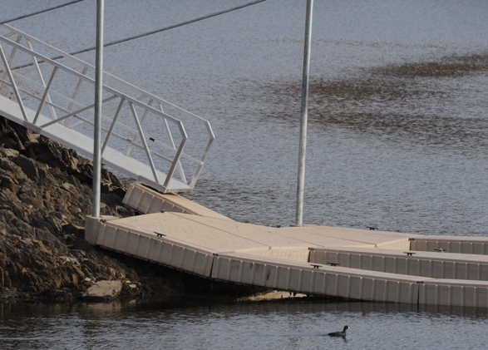
- Reduce Damage to Docks – The major 10-foot fluctuation of Lake Tulloch is very hard on docks and damages them costing property owners and homeowner association. Daniel Holman, President of HCI Docks notes “Simply put docks were made to float and we are constantly repairing these docks damaged by the fluctuation.

- Navigation and Dock – If the lake was maintained at a higher level, docks could be kept closer to shore. Lower water requires longer ramps.

- Erosion - When the lake is dropped 10 feed all of the land around the lake is subject to the continuing impact of weather. The purpose of the Shoreline Management Plan is to prevent degradation; a full lake serves that purpose.

- Tourism & Recreation – A fuller Lake Tulloch will encourage recreation. The use of modern-day wet suits now has surfers hitting the waves year-round on the coast and the same is true for water sports on a lake such as Tulloch. The attraction of fisherman would be greater too.
Conclusion

As an elected official, I am listening to my constituents and I believe that the prospect of adjusting the operation of Lake Tulloch in keeping it a higher level is something that the agencies of United States Government should consider in tandem with Tri Dam and other relevant parties including the counties of Tuolumne and Calaveras. I am proposing an objective analysis of this possibility and that it is essential a new policy does not compromise the safety and quality of the lake. Attached is a copy of the petition with input and thoughts from the public.

I have asked Congressman McClintock to look at the operation of Lake Tulloch and review the regulating component in the 2015 Shoreline Management Plan (SMP) as potentially unneeded which would permit the lake to retain its summer pool year-round. Doing so will further minimize shoreline degradation which is the goal of the 2015 SMP. This would require a re-opening of the agreement for the purpose of amending.

It is my hope that this short discussion paper accurately presents the reasons for the consideration of maintaining the lake at higher or even full levels year-round. It is important that the public has the facts on this important local question. The Lake Tulloch Basin is a major economic contributor to the region with its position on the Highway 4 Corridor and is the Gateway to the Sierra. The creation of a near year-round useable lake would be a substantial contributor to the economic revitalization of the Lake Tulloch Basin and the Mother Lode Region of California.

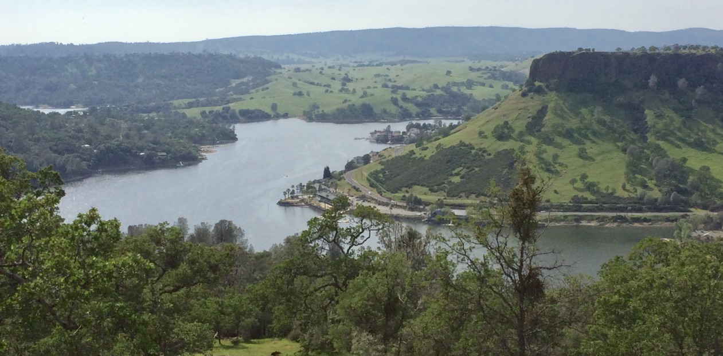
KEEPING LAKE TULLOCH FULL 365

For more than a half century Lake Tulloch has been regarded as one of the greatest recreational lakes in California even featured in national magazines. It has also become the home to thousands of people with the lake being one of the few reservoirs in the west with private property on its banks. Every year for more than 50 years the lake was always lowered in the fall and winter months and even into early spring. When the water is lowered the lake is difficult to access and most boats and many docks have to be moved to deeper water.

In the fall of 2018 a petition was spontaneously created by interested citizens that calls upon the United States Government to work with other agencies to create a plan to maintain the lake at a near full capacity. The following is the petition signed by nearly 400 citizens.

“We the citizens of the Lake Tulloch Basin support action by the United States Army Corps of Engineers in concert with other federal, state and local authorities to end the practice of lowering and raising Lake Tulloch in the fall and spring. This procedure is no longer needed for flood control since the New Melones Reservoir controls nearly all major water releases into the lake. Tulloch Dam was built in 1957 and Melones in 1979. We urge Congressman McClintock, and other public officials to support this proposal. This action will control erosion and provide a year-round recreational lake for hundreds of thousands of people in the region. It will also enhance the Lake Tulloch/Copperopolis Basin as a year-round recreational location, our community, our economy, and our way of life. We understand that the lowering of the lake may be required for repairs by Tri Dam, but it simply makes no sense to not maintain the lake at capacity the vast majority of days of the year.”

The following are many of the comments made by citizens signing the petition. There is a clearly a strong desire for the government to act on behalf of the public, the local economy and even the ecology and well-being of the lake itself.

Comments from the Public on the Petition Proposing the US Army Corps of Engineers
Establish a New Policy on Lake Tulloch’s Levels

- Living by the lake and only able to enjoy our boat and the lake only 5 months a year does not make sense!

- Maintaining the reservoir level year-round would also reduce the amount of bank erosion during the rainy season as more of the perimeter would remain submerged.

- We cannot launch our boat when the lake is lowered.

- It’s important for the local businesses to keep open during the off season. Many people would continue to use the lake year-round if the launch ramps were more accessible

- Copperopolis is a vibrant community - with many homeowners, a school, shops and restaurants. Lake Tulloch is also very beautiful with so much wildlife - including herons, bald eagles, and a rich variety of other birds. I think that having the lake higher for longer would be good for the fish and the animals and also attract visitors for longer which would be a great boost to the local economy which is badly needed

- Jobs/Environment/Real estate/Recreation: Year-round use and enjoyment means increased, steady revenue for local businesses, and likewise for employees at those businesses rather than downsizing due to offseason. Minimizing shore erosion due to wake action at fluctuating/lower lake levels (agree with 5yr maintenance draw down period needed). Year-round Accessibility & Recreation...convenient access to Drifters or south shore marina or visiting friends/family also living around the lake or enjoying various lake activities. Benefits of a full lake are endless; should be a no brainer concept!

- New Melones feeds into this lake and has plenty of capacity to hold run off during the winter/spring months. Lowering the lake negativity effects residents, the economy and water quality. As a resident of Folsom, I see the lake drained yearly because we have no upstream capacity, Tulloch does. Keep the water levels up year round

- Lake Tulloch has many retired full-time homeowners. Many family members travel to visit their parents or friends to enjoy the lake and create wonderful memories. The weather is such that the lake can be enjoyed for fishing, kayaking, boating, and swimming year-round. The local businesses are hurt by lack of tourism from Sept to May. As others commented, there is no necessity to lower the lake every year except for maintenance of the dam.

- This is important to me because I would like to have water to kayak year-round not only a few months out of the year. It would also support small businesses stay in businesses and even raise our house values. Keep Lake Tulloch full year-round.

- This will help make the area economically more viable and a better place to live.

- This is only logical, and it would improve year-round access to the lake for year-round residents as well as those vacationers who are able to take advantage of the less crowded fall, winter and spring seasons.

- Extending the high-water season would be beneficial for our local economy, environment, recreational uses and water management

- Better for the local economies and the residents that live around the lake. Also, more storage of water for drinking and the agricultural communities down river from Tulloch

- No reason not to. It is important to our community. Why would you not keep it full. What is a good reason?

- This is important to me because it directly affects me. I own a home on the lake and when the water is lowered during the winter, I cannot launch my boat. I enjoy fishing, boating, and jet skiing year-round, but I cannot access the lake during the winters. This lack of winter access also affects my home value.

- For recreation and wildlife support and because there is no longer a reason to draw down 10 feet since the New Melones dam was built
- The lake should be usable all year but cannot be because our ramp is out of the water. Let's use it all year long! That should raise all our property values.

- It will be advantageous to have access to the lake year-round for full time homeowners to use but also for economic growth to have more visitors in the off season who come and eat at the restaurants and shop while they are staying at the lake or just fishing for the day.

- Will increase property values and stimulate local economy? Would potentially attract additional restaurants and businesses in the area if there were more non-summer visitors due to a full lake.

- Living fulltime on the lake, i only have water at my backyard during the summer months due to the water draw. The fishing is better in the cooler months; the weather is usually nice enough for boating the majority of the year. Drawing the water level down makes it difficult to enjoy the lake, not to mention the increased insect population. Please consider keeping Lake Tulloch full year-round!

- The ability to enjoy the recreational benefits of my home are limited by the lowering of the lake 9 months out of the year. It also has an economic effect as it relates to real estate values, in addition to the local area economy which relies upon its business for 3 months of the year to provide annual incomes.

- This lake is the life blood of this community.

- Year-round access and availability of recreational use of the lake helps not only the residents but also attracts other users from surrounding areas which helps the economy and property values in our area. Tulloch is one of the few lakes with year-round homes around its shores. We have to annually move our boat docks back and forth as well as not have the use of the lake for the winter. Occasional lowering for maintenance is of course necessary and understandable.

- Eliminates need to remove boats & docks. Plus, we pay for slips for full year and only get 6 months usage.

- I would love to be able to enjoy the lake year-round with my children. Go fishing and patron the businesses that we love during the summer. Also, purchasing property would be way more appealing as well.

- Since the construction of New Melones Reservoir, the data shows that the lowering of the Lake Tulloch Reservoir is not necessary for flood control. In addition, research and evidence presented has shown that the practice of lowering the Lake Tulloch Reservoir in order to protect certain wildlife is also ineffective, unnecessary and wasteful. Many residents, including ourselves, live on Lake Tulloch year-round and the annual lowering of the Lake Tulloch Reservoir limits our use and others wanting to use the lake for a significant portion of the year when the water levels are lowered. Please discontinue this unnecessary and wasteful practice for the benefit of all parties involved.

- After owning property on the lake for over 50 years it is time to end this practice of lowering the lake levels each year. I do support the lowering of the lake periodically (once every 5 years) to enable waterfront work/maintenance.

- My family owns property on the water and I am a Contractor that builds on the water. The fluctuation of the water level wreaks havoc on the retaining walls around the lake undermining the walls and causes damage to docks. when the water level is low during the winter it erodes the new shoreline that is exposed that would have been underwater during the summer

- I live here, taking water out erodes the land under the homes, also the pressure from the water holds the land, you keep on filling up and letting out water the lad will slide, one house is going into the lake already. maybe do this to the release of over 10ft water ever year, and 20 ft. every 5 years to check damn. all just a water grab.

- Keep recreation going all year. Keep access to launch ramps open all year when water level drops some ramps are not usable.

- Businesses survive and thrive from visitors to our lake community.

- This is important to me because this lake brings revenue to our town. It’s important to keep what we have as far as restaurants on the lake open and with business to support it. Seasonal makes things rough. In case of a real drought why let out water out when it may not be able to be replaced.

